**TEST CASES OF COVID 19 SYMPTOMS CHECKER**

1. Test Case: Open the application.

<https://covidiawork.pythonanywhere.com> – the link which navigates to the COVID – 19 Symptoms checker application.

Result: Launching the web application.

1. Test Case: User Login Validation

Steps for New User

1. if user is new to web application, then provide the details in the sign-up page by giving the details like

Username

Email

Password

Result: Sign up successful

1. After signing up, navigate to the Sign in Page and give the below details and login.

Username

Password

Result: Login Successful

1. If the valid username is given, then the user will be able to login to the application.

Result: Invalid Credentials

1. If the invalid credentials like if the username or the password given are wrong, then it fails to login and says, “Invalid Credentials”.

Result: Invalid Credentials

Steps for Existing User

1. Navigate to Login page and enter the username and password.

Result: Login Successful

1. If the credentials provided are correct, then it will allow the user to login to the application.

Result: Invalid Credentials

1. If credentials are wrong, then it says Invalid credentials.

Result: Invalid Credentials

1. Test Case: Navigating to the Links provided.
   1. There are two links available after logging in to the application.
      1. Link to check the details provided by the World Health Organization
      2. Link to navigate to the chat bot.
   2. Tested by clicking the first link “[Click here](https://www.who.int/emergencies/diseases/novel-coronavirus-2019)for more information regarding Covid-19” and it is navigating to the WHO details.

Result: successfully opening the details after clicking on the link

* 1. Tested by clicking the second link “[Click here to interact with Covidia](https://covidiawork.pythonanywhere.com/CovidiaTest)” and it successfully navigate to the chat bot.

Result: successfully opening the Chat bot after clicking on the link.

1. Test case: Chat Bot validation

The following are a few steps to validate the testing of the web application.

1. Enter the empty input in the chat window.

Result: “Input field is empty, could you give me the answer to the question.”.

1. Next, answer the questions that popped up in the chat bot and check if the chat analysis the answers and provide the results or not based on the information given.
   * 1. In the first scenario, I have given the details as NO to every question then the expected result is no covid symptoms.

Result: ***You have no obvious symptoms related to Covid-19 😄. It is recommended that you engage in regular physical exercise, refrain from attending crowded gatherings, and keep me updated on your health status on a daily basis.***

* + 1. In the second scenario, I have given the details as YES to every question then the expected result is advisable to take test.

Result:” ***Based on your symptoms of Covid 19. It's advisable to get tested for COVID-19 and seek medical attention.***”

* + 1. In the third scenario, I have given the details as YES to most of the questions and no to lesser questions then the expected result is advisable to take test.

Result:” ***Based on your symptoms of Covid 19. It's advisable to get tested for COVID-19 and seek medical attention.***”

* + 1. In the last scenario, I have tried giving No to most of the questions and yes to lesser questions then the expected results should be No covid.

Result:” ***You have no obvious symptoms related to Covid-19 😄. It is recommended that you engage in regular physical exercise, refrain from attending crowded gatherings, and keep me updated on your health status on a daily basis.***”

1. Test case: Speech to text validation

The speech to text is validated using the mic button provided in the chat bot. The Job of the speech to text is to convert the chat provided by the user by speech to text in the chat.

Initially it asks the user to allow the microphone.

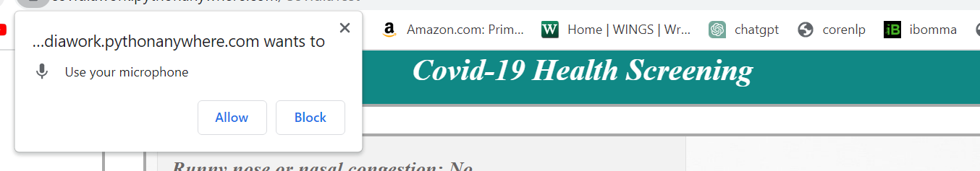

After clicking on the allow the user will be able to talk.

I have given the input by saying ***this is my distributed computing Project covid-19 online diagnosis speech to text API testing*** and the speech to text is converted correctly and it is working efficiently.